Sunday, May 11, 2025
+ St. Joseph Catholic Church +
130 S. 4th St., Rio Vista 94571
– www.stjosephriovista.org –
Fourth Sunday of Easter, page 158
HAPPY MOTHER’S DAY
Cuarto Domingo de Pascua, página 156
FELIZ DÍA DE LAS MADRES
Mass Intentions
Ofrecimiento de la Misa
5/10 @ 5:00 +Andrea Wong
5/11 @ 8:00 +Sybil and +Scott Sinclair
5/11 @10:00 +Nick Cruz
5/11 @12:00 David and Mark Vega and their families (Special Intentions) and Matteo Vega (Happy Birthday)
5/13 @ 8:00 +Ben Perez
5/14 @ 8:00 People of the Parish
5/15 @ 8:00 People of the Parish
5/16 @ 8:00 +Teresita Medina-Palomares (Death Anniversary)

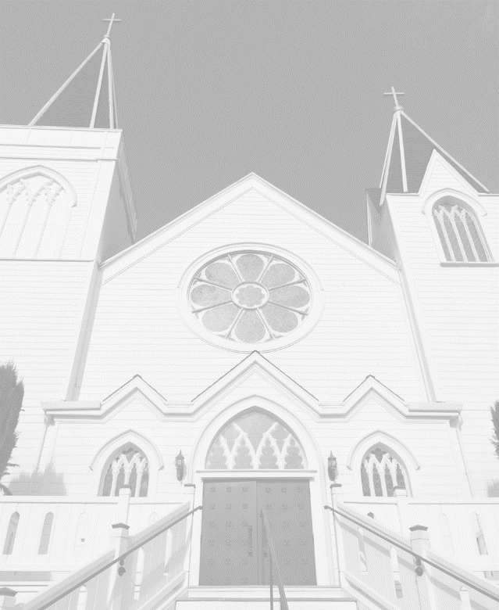
UPCOMING EVENTS

May 10-11: Fourth Sunday of Easter

May 11: Happy Mother’s Day

May 12: The Church choir door will be open for private devotions from 9:15-11:00AM

May 14: FAITH FORMATION – the Last Class of the 2024-2025 school year.

May 17: Rio Vista Care Gala

May 17-18: Fifth Sunday of Easter

May 19: Private devotions in the Church from 9:15-11:00AM.

May 24-25: Sixth Sunday of Easter.
May 24-25: Rio Vista Food Pantry Donation weekend, cash or check donations only.

May 25: Coffee Social after all three Masses in the Parish Hall, hosted by YLI.

May 26: Memorial Day. The Parish Office and the Church will be closed.

May 31-June1: The Solemnity of the Ascension of the Lord. Catholic Communication Campaign. Donation envelopes will be available.

June 2: Private devotions in the Church from 9:15-11:00AM.

June 6: First Friday; Mass at 8:00AM, Adoration and Benediction to follow until 3:00PM.

MONTHLY FINANCIAL REPORT
Sunday Collection 5/4 $ 5,969.28
Building Fund – May $ 2,510.65
Catholic Home Missions-Total $ 377.00
Easter – New total $ 8,891.35
Thank you for your continued support.

“The courage and strength that are in me are not of me, but of Him who lives in me – it is the Eucharist.”
St. Faustina Kowalska

“El valor y la fuerza que hay en mí no son de mí, sino de Aquel que vive en mí – es la Eucaristía.”
Santa Faustina Kowalska

Fr. Mervin Concepcion,
Pastor
fathermervinc@comcast.net
Deacon Bill Bolduc
WEEKLY MASS SCHEDULE
Saturday (Vigil): 5:00PM
Sunday: 8:00AM & 10:00AM
12:00PM (en Español/in Spanish)
Weekdays: Tues. – Fri. @ 8:00AM
Sacrament of Reconciliation:
Sat. 4:00PM – 4:45PM or by appointment
Sacrament to the Sick/Homebound
Please call the Office
PARISH OFFICE HOURS:
Janet Campbell, Secretary
(707) 374-2155 or (707) 375-3455
Mon. – Fri. 9:00AM-4:00PM
(CLOSED for lunch 1:00PM-2:00PM)
stjosephoffice@comcast.net
PARISH HALL
Please contact the office (707) 374-2155 for keys/information concerning the Hall.
PARISH PASTORAL COUNCIL
3rd Tuesday of the Month,

FINANCE COUNCIL
2nd Tuesday of the Month
Mike Pine, Chair
BEREAVEMENT COMMITTEE
Please contact the Parish Office
CHOIR PRACTICE
Thursdays
BAPTISMS
2nd & 4th Saturday of each month at 11:00am. Preparation classes for parents & Godparents on the 1st Wednesday (in Spanish at 6:00PM) and the 1st Thursday (in English at 5:30PM) in the Parish Hall at 5:30PM. You must call the office to enroll in any class or schedule a Baptism.
FAITH FORMATION
Elsa Vega – Coordinator
Susan Jeongco – Assistant Coordinator
Classes – Wednesdays 2:00-4:00
stjosephcatechism@comcast.net
(707) 374-2607
YOUTH GROUP
Sunday at 7:00PM in Parish Hall
High School Students
RITE OF CHRISTIAN INITIATION FOR ADULTS (RCIA).
Please contact the office for information
“FIRST FRIDAYS”
Mass @ 8:00 AM, Exposition & Adoration of the Eucharist 8:30 – 3:00 followed by Benediction.
ST. VINCENT dePAUL – For assistance:
(707) 374-3426 Monday – Friday
Wendy Ross – President
KNIGHTS OF COLUMBUS
1st Tuesday of the Month
Dennis Ortega – Grand Knight
YOUNG LADIES INSTITUTE
3rd Tuesday of the Month-11:00AM
Meri Wheeler – President
HAPPY MOTHER’S DAY
PRAYER OF GRATITUDE
“Loving and Gracious God, my heart is filled with deep gratitude to you for the gift of my mother and all those who have been mothers to me in my life, enfolding me and blessing me with their compassionate hearts. May you continue to bless them and hold them close in your loving embrace.” AMEN.
JUBILEE YEAR: PILGRIMS OF HOPE
CORPUS CHRISTI EUCHARISTIC PROCESSION
Celebrate this Jubilee Year by participating in the Diocese of Sacramento’s Eucharistic Procession, June 19 – 21, 2025. The pilgrimage will begin Thursday, June 19th with Mass at 7:45AM at St. Catherine’s in Vallejo. There will be a procession on foot from St Catherine to St. Basil, also in Vallejo. After 1 hour of Adoration, they will process to St. Vincent for another hour of adoration. Then to the Vallejo Municipal Marina where the sacred Eucharist will travel by water to the City Dock at the end of Main Street in Rio Vista. The boat is scheduled to arrive at 3:00PM. There will be a procession from the dock to St. Joseph Church. There will be Overnight Adoration. On Friday, June 20th, we will have Benediction at 8:00AM, followed by a procession to the City Boat Dock. The Eucharist is scheduled to arrive in Isleton at 10:00AM and there is a Mass scheduled at St. Therese at 11:00AM. Adoration at St. Anthony in Walnut Grove is from 2:30 to 3:00PM. Overnight Adoration on Friday night will be at St. Joseph in Clarksburg. There is a big celebration scheduled for Saturday in Sacramento, ending with Adoration at the Cathedral at 5:00PM.
VOLUNTEERS NEEDED
On Thursday, June 19th, we will be having overnight Adoration. According to the Catechism of the Catholic Church, #2628, “Adoration is the first attitude of man acknowledging that he is a creature before his Creator. It exalts the greatness of the Lord who made us and the almighty power of the Savior who sets us free from evil. Adoration is homage of the spirit to the ‘King of Glory,’ respectful silence in the presence of the ‘ever greater’ God. Adoration of the thrice holy and sovereign God of love blends with humility and gives assurance to our supplications.” Everyone is encouraged to come. Father Mervin would like to have a schedule of people to spend one hour of Adoration. If you can commit to one specific hour from the time the Eucharist arrives at, roughly, 4:00PM on Thursday to Benediction at 8:00AM Friday, please call the office.
BLESSED CARLO ACUTIS
“Blessed Carlo Acutis, you used your gifts to bring light to the world, sharing the beauty of the Eucharist and the truth of the Gospel through the internet. You recognized the power of technology as a tool for spreading love, kindness, and faith. Help us, in our daily online lives, to follow your example of humility, to use technology not for selfishness, but to uplift and connect others with goodness. Guide us to avoid the traps of negativity and distraction and teach us to see the internet as a means to glorify God, promote peace, and build bridges of unity. Blessed Carlo, pray for us, that we may find the courage to live as authentic Christians, both online and offline, so that like you, we may grow closer to Jesus and inspire others to do the same.” Amen.
FELIZ DÍA DE LAS MADRES
ORACIÓN DE GRATITUD
“Dios bondadoso y gracioso, mi corazón está lleno de profunda gratitud hacia ti por el don de mi madre y de todas las que han sido madres para mí en mi vida, envolviéndome y bendiciéndome con sus corazones compasivos. Que continúes bendiciéndolas y sosteniéndolas en tu amoroso abrazo.” Amen.
AÑO JUBILAR: PEREGRINOS DE LA ESPERANZA PROCESIÓN EUCARÍSTICA DEL CORPUS CHRISTI
Celebre este Año Jubilar participando en la Procesión Eucarística de la Diócesis de Sacramento, del 19 al 21 de junio 2025. La peregrinación comenzará el jueves, 19 de junio, con la Misa a las 7:45 horas en Santa Catalina, Vallejo. Habrá una procesión a pie desde Santa Catalina hasta San Basilio, también en Vallejo. Después de 1 hora de Adoración, procesionarán a San Vicente para otra hora de adoración. Luego al Puerto Municipal de Vallejo donde la sagrada Eucaristía viajará por barco hasta el muelle de Rio Vista, al final de la Calle Main. La llegada del barco está programada para las 15:00 horas. Habrá una procesión desde el muelle hasta la Iglesia de San José. Habrá adoración nocturna. El viernes, 20 de junio, tendremos la bendición a las 8:00 horas, seguida de una procesión al muelle de la ciudad. La Eucaristia está programada llegar a Isleton a las 10:00 horas y hay una Misa programada en la Iglesia Santa Teresita a las 11:00 horas. La adoración en la Iglesia San Antonio en Walnut Grove es de las 14:30 a 15:00 horas. La adoración nocturna del viernes por la noche será en la Iglesia San José en Clarksburg. Hay una gran celebración programada para el sábado en Sacramento, cual terminará con la Adoración en la Catedral a las 17:00 horas.
SE NECESITAN VOLUNTARIOS
El jueves, 19 de junio, tendremos Adoración nocturna. Según el Catecismo de la Iglesia Católica, #2628, “La adoración es la primera actitud del hombre que se reconoce criatura ante su Creador. Exalta la grandeza del Señor que nos hizo y el poder omnipotente del Salvador que nos libera del mal. La adoración es homenaje del espíritu al ‘Rey de la gloria’, silencio respetuoso en presencia del Dios ‘siempre más grande’. La adoración al Dios de amor, tres veces santo y soberano, se funde con la humildad y da seguridad a nuestras súplicas.” Se anima a todos a venir. Al Padre Mervin le gustaría tener un horario de personas para pasar una hora de Adoración. Si puede comprometerse a una hora específica desde el momento en que llegue la Eucaristía, alrededor de las 16:00 horas el jueves hasta la Bendición a las 8:00 horas el viernes, por favor llame a la oficina.
BEATO CARLO ACUTIS
“Beato Carlo Acutis, utilizaste tus dones para llevar luz al mundo, compartiendo la belleza de la Eucaristía y la verdad del Evangelio a través del internet. Reconociste el poder de la tecnología como instrumento para difundir el amor, la bondad, y la fe. Ayúdanos, en nuestra vida diaria en la red, a seguir tu ejemplo de humildad, a utilizar la tecnología no para el egoísmo, sino para elevar y conectar a los demás con la bondad. Guíanos para evitar las trampas de la negatividad y la distracción y enséñanos a ver el internet como un medio para glorificar a Dios, promover la paz, y construir puentes de unidad. Bendito Carlo, ruega por nosotros, para que encontremos el valor de vivir como auténticos cristianos, tanto en la red como afuera, para que como tú, podamos crecer más cerca de Jesús e inspirar a otros a hacer lo mismo.” Amén.

